

**MGM’s POLYTECHNIC, AURANGABAD**

**2020-2021**

Micro Project Report

On

**“Make the chart on Brakes”**

Submitted in partial fulfillment for ‘I’ Scheme forth semester of

**Diploma in**

**MECHANICALENGINEERING**

**By**

**DHAKNE RAMAKANT MAHENDRA ( 1915010275 )**

**MOHAMMED SAAD SAYYED ( 1915010276 )**

**JADHAV SWARAJ MILIND ( 1915010277 )**

Under the guidance of

**Prof. Parihar A. A.**

(Lecturer in Mechanical Engineering)

***In Pursuit of Excellence***



[**Maharashtra State Board of Technical Education, Mumbai**](http://msbte.org.in/)

**(Autonomous) (ISO-9001-2008) (ISO/IEC 27001:2013)**



**Maharashtra State**

**Board of Technical Education, Mumbai**

**Certificate of Completion**

This is to certify that **DHAKNE RAMAKANT MAHENDRA , MOHAMMED SAAD SAYYED ,JADHAV SWARAJ MILIND** with Enrollment No: **1915010275 , 1915010276 , 1915010277** have successfully completed their Micro-Project entitled **“Make the chart on Brakes”** in the Course/Subject of **"22438 - Theory of Machines”**in the forth semester during thier tenure of completing the Diploma programme in **Mechanical Engineering** From **MGM's Polytechnic** institute with institute code **1501.**

**Prof. Parihar A. A. Prof. Bhalekar B.D**

**Course Coordinator HOD**

Mechanical Engineering Mechanical Engineering

**Dr. B. M. Patil**

**Principal**

**INDEX**

|  |  |  |
| --- | --- | --- |
| **Sr. No.** | **Content** | **Page No.** |
| **Micro-Project Proposal (ANNEXURE-I)** | |  |
| 1.0 | Aims/Benefits of the Micro-Project | 1 |
| 2.0 | Course Outcomes Addressed | 1 |
| 3.0 | Proposed Methodology | 1 |
| 4.0 | Action Plan | 1 |
| 5.0 | Resources Required | 2 |
|  |  |  |
| **Micro-Project Report (ANNEXURE-II)** | |  |
| 1.0 | Rationale | 3 |
| 2.0 | Aims/Benefits of the Micro-Project | 3 |
| 3.0 | Course Outcomes Achieved | 3 |
| 4.0 | Literature Review | 3 |
| 5.0 | Actual Methodology Followed | 4 |
| 6.0 | Actual Resources Used | 4 |
| 7.0 | Outputs of the Micro-Projects | 5 |
| 8.0 | Skill Developed / Learning outcomes of this Micro-Project | 5 |
| 9.0 | Applications of this Micro-Project | 5 |

**Annexure – I**

**Micro-Project Proposal**

**Make the chart on Brakes**

1. **Aims/Benefits of the Micro-Project**

The brakes are responsible for stopping the wheels from spinning. It's the job of the brake pads and brake discs to create the resistance needed to cause this action and each time your vehicle brakes the discs begin to wear

**2.0 Course Outcomes Addressed**

* Select relevant brakes and clutches for various applications
* Calculate breaking torque required in different breaks at different speeds and load situations

**3.0 Proposed Methodology**

1. We will finalize micro project team.
2. We will finalize topic for micro project.
3. We will prepare certificate and proposal of report.
4. Then we will collect information based on Brakes
5. We will prepare a Model on Brakes
6. And we will make power point presentation based on micro project.
7. Then at last we will derive a chart on Brakes.

**4.0 Action Plan**

|  |  |  |  |  |
| --- | --- | --- | --- | --- |
| **S. No.** | **Details of activity** | **Planned Start date** | **Planned Finish date** | **Name of Responsible Team Members** |
|  | Finalization of Micro Project Team | 1 may 2021 | 2 may 2021 | Sayyed saad , swraj jadhav and ramakant dhakne |
|  | Finalization of Topic | 3 may 2021 | 4 may 2021 |
|  | Literature Survey | 5 may 2021 | 6 may 2021 | Sayyed saad , and ramakant dhakne |
|  | Submission of Micro-Project Proposal (ANNEXURE-I) | 7 may 2021 | 8 may 2021 | Sayyed saad , swraj jadhav and |
|  | Proposed Methodology | 8 may 2021 | 9 may 2021 | Sayyed saad , and ramakant dhakne |
|  | Collecting Resources Required (raw material) | 10 may 2021 | 10 may 2021 | Sayyed saad , swraj jadhav and |
|  | Making of Chart | 10 may 2021 | 10 may 2021 | Sayyed saad , swraj jadhav and ramakant dhakne |
|  | Submission of Micro-Project Report (ANNEXURE-II) | 10 may 2021 | 10 may 2021 | Sayyed saad , |
|  | Presentation via PPT to Institute | 10 may 2021 | 10 may 2021 | Sayyed saad , |

**5.0 Resources Required**

|  |  |  |  |  |
| --- | --- | --- | --- | --- |
| **S. No.** | **Name of Resource/material** | **Specifications** | **Qty.** | **Remarks** |
|  | chart | information | 1 |  |
| 2 | TOM manual | Outcomes | 1 |  |
| 3 | Laptop or computer | - | 1 |  |
| 4 | Wikipedia | For gathering information | - |  |
| 5 | Google | For downloading image | - |  |

**Name of Team Members Roll No’s:**

1. DHAKNE RAMAKANT MAHENDRA 22113
2. MOHAMMED SAAD SAYYED 22114
3. JADHAV SWARAJ MILIND 22115

**\*\*\*\*\*\*\*\*\*\*\*\*\*\***

**Annexure – II**

**Micro-Project Report**

**Make the chart on Brakes**

**1.0 Rationale**

A brake is a mechanical device that inhibits motion by absorbing energy from a moving system. It is used for slowing or stopping a moving vehicle, wheel, axle, or to prevent its motion, most often accomplished by means of friction.

**2.0 Aims/Benefits of the Micro-Project:**

* To study and Make the chart on Breaks and its types
* To understand components of Breaks

**3.0 Course Outcomes Achieved**

* Estimate Breaks in machine components.
* Perform test to evaluate mechanical properties according to Indian Standard.

**4.0 Literature Review**

Most brakes commonly use friction between two surfaces pressed together to convert the kinetic energy of the moving object into heat, though other methods of energy conversion may be employed. For example, regenerative braking converts much of the energy to electrical energy, which may be stored for later use. Other methods convert kinetic energy into potential energy in such stored forms as pressurized air or pressurized oil. Eddy current brakes use magnetic fields to convert kinetic energy into electric current in the brake disc, fin, or rail, which is converted into heat. Still other braking methods even transform kinetic energy into different forms, for example by transferring the energy to a rotating flywheel.

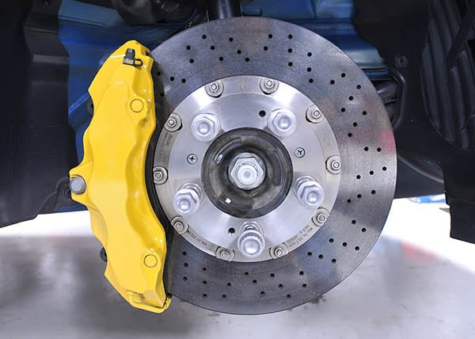

Brakes are generally applied to rotating axles or wheels, but may also take other forms such as the surface of a moving fluid (flaps deployed into water or air). Some vehicles use a combination of braking mechanisms, such as drag racing cars with both wheel brakes and a parachute, or airplanes with both wheel brakes and drag flaps raised into the air during landing.

Since kinetic energy increases quadratic ally with velocity

({\display style K=mv^{2}/2}K=mv^{2}/2),

an object moving at 10 m/s has 100 times as much energy as one of the same mass moving at 1 m/s, and consequently the theoretical braking distance, when braking at the traction limit, is up to 100 times as long. In practice, fast vehicles usually have significant air drag, and energy lost to air drag rises quickly with speed.

Brakes may be broadly described as using friction, pumping, or electromagnetics. One brake may use several principles: for example, a pump may pass fluid through an orifice to create friction:

1. **Frictional**

Frictional brakes are most common and can be divided broadly into "shoe" or "pad" brakes, using an explicit wear surface, and hydrodynamic brakes, such as parachutes, which use friction in a working fluid and do not explicitly wear. Typically the term "friction brake" is used to mean pad/shoe brakes and excludes hydrodynamic brakes, even though hydrodynamic brakes use friction. Friction (pad/shoe) brakes are often rotating devices with a stationary pad and a rotating wear surface. Common configurations include shoes that contract to rub on the outside of a rotating drum, such as a band brake; a rotating drum with shoes that expand to rub the inside of a drum, commonly called a "drum brake", although other drum configurations are possible; and pads that pinch a rotating disc, commonly called a "disc brake"

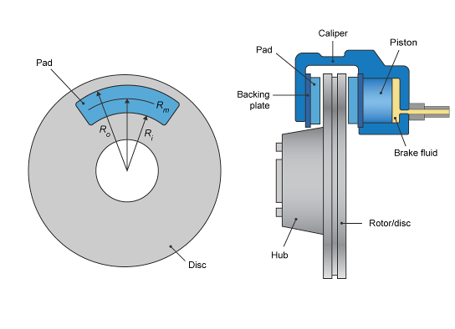

1. **Pumping**

Pumping brakes are often used where a pump is already part of the machinery. For example, an internal-combustion piston motor can have the fuel supply stopped, and then internal pumping losses of the engine create some braking. Some engines use a valve override called a Jake brake to greatly increase pumping losses. Pumping brakes can dump energy as heat, or can be regenerative brakes that recharge a pressure reservoir called a hydraulic accumulator.

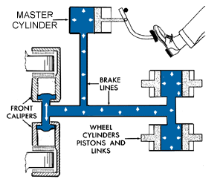

1. **Electromagnetic**

Electromagnetic brakes are likewise often used where an electric motor is already part of the machinery. For example, many hybrid gasoline/electric vehicles use the electric motor as a generator to charge electric batteries and also as a regenerative brake. Some diesel/electric railroad locomotives use the electric motors to generate electricity which is then sent to a resistor bank and dumped as heat. Some vehicles, such as some transit buses, do not already have an electric motor but use a secondary "retarder" brake that is effectively a generator with an internal short circuit. Related types of such a brake are eddy current brakes, and electro-mechanical brakes (which actually are magnetically driven friction brakes, but nowadays are often just called "electromagnetic brakes" as well).

Electromagnetic brakes slow an object through electromagnetic induction, which creates resistance and in turn either heat or electricity. Friction brakes apply pressure on two separate objects to slow the vehicle in a controlled manner.

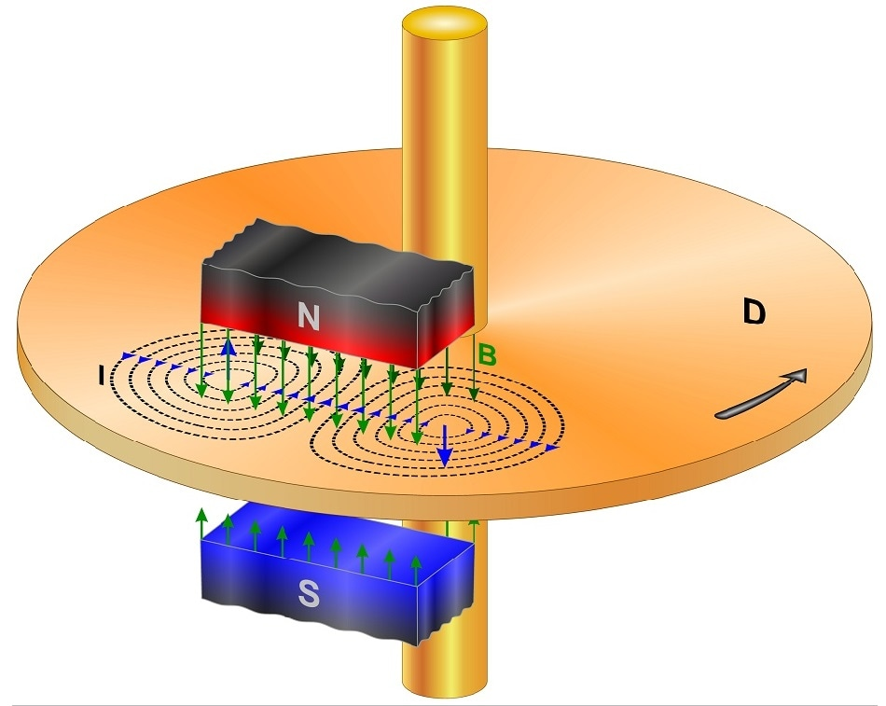 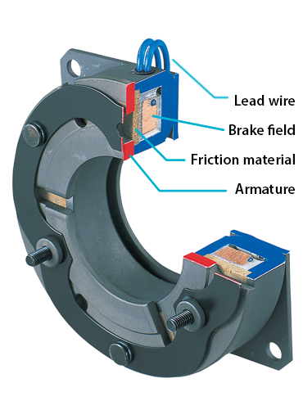

* **Brakes are often described according to several characteristics including:**

1. **Peak force** – The peak force is the maximum decelerating effect that can be obtained. The peak force is often greater than the traction limit of the tires, in which case the brake can cause a wheel skid.
2. **Continuous power dissipation** – Brakes typically get hot in use and fail when the temperature gets too high. The greatest amount of power (energy per unit time) that can be dissipated through the brake without failure is the continuous power dissipation. Continuous power dissipation often depends on e.g., the temperature and speed of ambient cooling air.
3. **Fade** – As a brake heats, it may become less effective, called brake fade. Some designs are inherently prone to fade, while other designs are relatively immune. Further, use considerations, such as cooling, often have a big effect on fade.
4. **Smoothness** – A brake that is grabby, pulses, has chatter, or otherwise exerts varying brake force may lead to skids. For example, railroad wheels have little traction, and friction brakes without an anti-skid mechanism often lead to skids, which increases maintenance costs and leads to a "thump thump" feeling for riders inside.
5. **Power** – Brakes are often described as "powerful" when a small human application force leads to a braking force that is higher than typical for other brakes in the same class. This notion of "powerful" does not relate to continuous power dissipation, and may be confusing in that a brake may be "powerful" and brake strongly with a gentle brake application, yet have lower (worse) peak force than a less "powerful" brake.
6. **Pedal feel** – Brake pedal feel encompasses subjective perception of brake power output as a function of pedal travel. Pedal travel is influenced by the fluid displacement of the brake and other factors.
7. **Drag** – Brakes have varied amount of drag in the off-brake condition depending on design of the system to accommodate total system compliance and deformation that exists under braking with ability to retract friction material from the rubbing surface in the off-brake condition.
8. **Durability** – Friction brakes have wear surfaces that must be renewed periodically. Wear surfaces include the brake shoes or pads, and also the brake disc or drum. There may be tradeoffs, for example, a wear surface that generates high peak force may also wear quickly.
9. **Weight** – Brakes are often "added weight" in that they serve no other function. Further, brakes are often mounted on wheels, and unsprung weight can significantly hurt traction in some circumstances. "Weight" may mean the brake itself, or may include additional support structure.
10. **Noise** – Brakes usually create some minor noise when applied, but often create squeal or grinding noises that are quite loud.

**5.0 Actual Methodology Followed**

1. We finalize a micro project team.
2. We finalize micro project topic based on syllabus.
3. We prepared proposal of micro project.
4. We distributed work of micro project into 3 team members as per their skills.
5. Collection of information/details required to was done by Saad Sayyed
6. Making of Model was done by Sawraj Jadhav and Saad Sayyed
7. Compose, typing and drafting of chart done by Ramakant Dhakne
8. Literature review is done by Sayyed Saad

**6.0 Actual Resources Used**

|  |  |  |  |  |
| --- | --- | --- | --- | --- |
| **S. No.** | **Name of Resource/material** | **Specifications** | **Qty.** | **Remarks** |
|  | chart | information | 1 |  |
| 2 | TOM manual | Outcomes | 1 |  |
| 3 | Laptop or computer | - | 1 |  |
| 4 | Wikipedia | For gathering information | - |  |
| 5 | Google | For downloading image | - |  |

* 1. **Outputs of the Micro-Projects**

Micro project helps to understand components, functions and applications of Breaks. With the help of our micro project you can easily understand how breaks work and how they are useful for safety.

**8.0 Skill Developed / Learning outcomes of this Micro-Project**

We developed skills as follows:

* **Communication skills.**
* **Leadership skills.**
* **Team management skills.**
* **Time management skills.**
* **Problem-solving skills.**
* **Technical writing skills.**
* **Reporting skills.**
* **Adaptability.**
* **Project management methodologies.**
  1. **Applications of this Micro-Project:**
* It is used for slowing or stopping a moving vehicle, wheel, axle, or to prevent its motion, most often accomplished by means of friction.
* It's the job of the brake pads and brake discs to create the resistance needed to cause this action and each time your vehicle brakes the discs begin to wear.
* It allows the driver to slow or stop the vehicle and prevents a stationary vehicle from moving. ... Modern ABS versions not only prevent wheel lock under braking, but also electronically control the front-to-rear brake bias.

**\*\*\*\*\*\*\*\*\*\*\*\*\*\***